1.

"I was born with a silver spoon in my mouth."

"I grew up overnight."

"At the crack of dawn..."

"....I got up with the chickens."
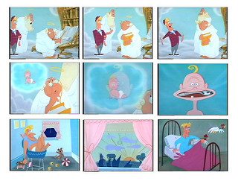

2.

"I got a job slinging hash..."

"...because the proprietor was short-handed."

"But I couldn't cut the mustard..."

"...so the guy gave me the gate."

"I went back to my hole in the wall."

"I was beside myself with anger."

"I decided to get a train ticket to Texas. There I made some dough punching some cattle."

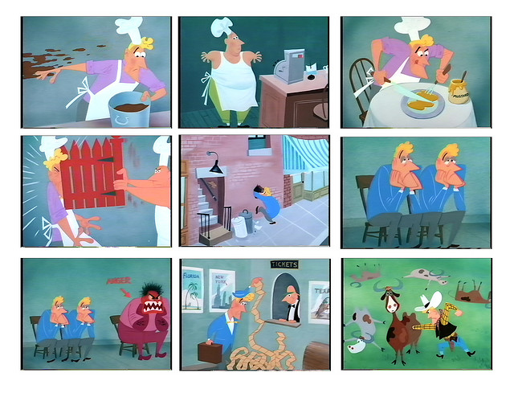

3.

"From there, I flew to Chicago."

"There, a beautiful girl stepped into the picture."

"Our eyes met."

"My breath came in short pants."

"And I had goose pimples."

"I was all thumbs."

"Mary's clothes fit her like a glove."

"...with her hair done up in a bun."

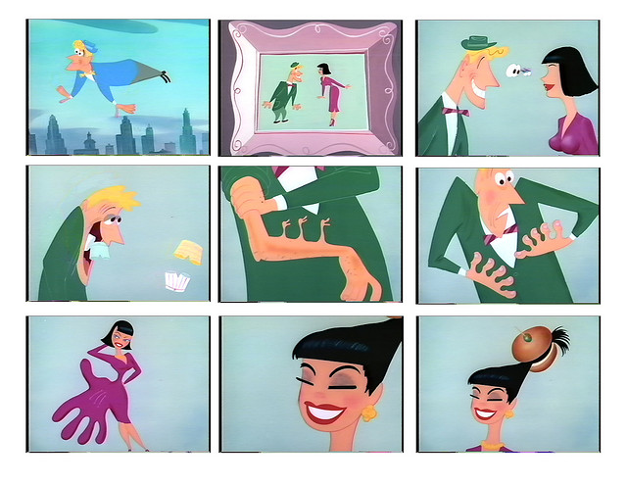

4.

"She had good lookin' pins too!"

"Finally, she gives me a date."

"I put on my white tie and tails."

"And brother, did she put on the dog!"

"We went around together for some time..."

"...painting the town red...."

"...going to the Stork Club..."
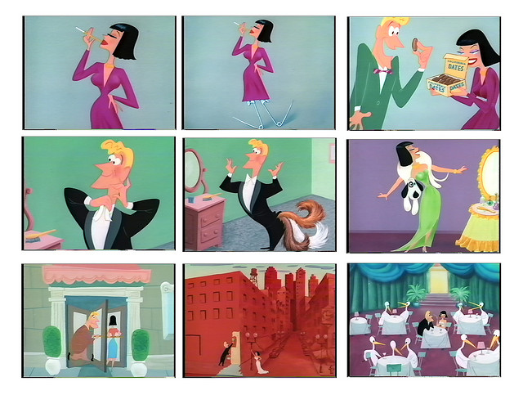
5.

"...we had a box at the opera."

"...I had a cocktail and Mary had a Moscow Mule."

"...Mary let her hair down..."

"...and ate like a horse."

"By then, my money started running out on me."

"So I wrote a check. It bounced!"

"I was in a pickle..."
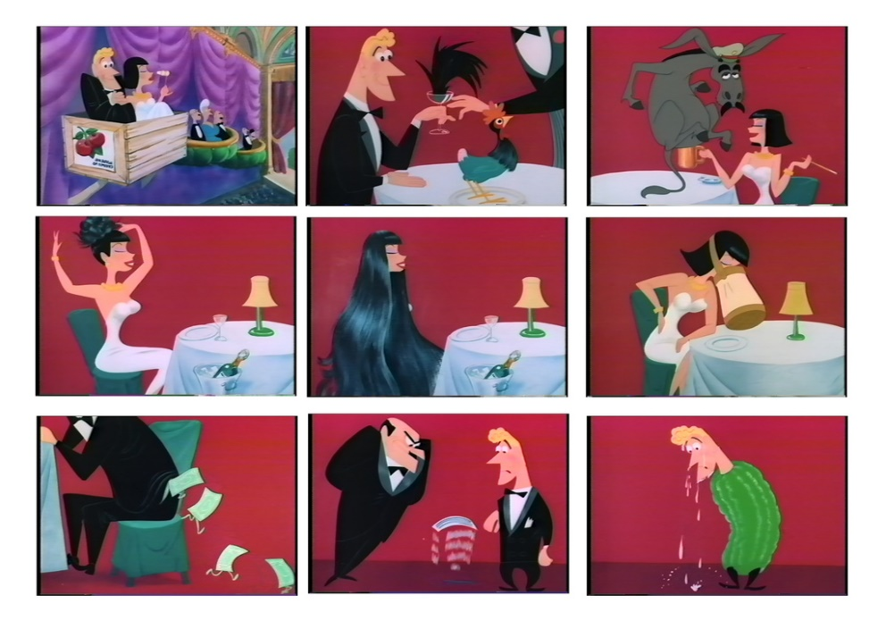
6.

"The proprietor drew a gun on me."

"So I gave him the slip..."

"...and head to the foothills."

"The law was on my heel."

"...the judge tried to pump me."

"...everytime I opened my mouth, I put my foot in it."

"So he sent me up the river..."
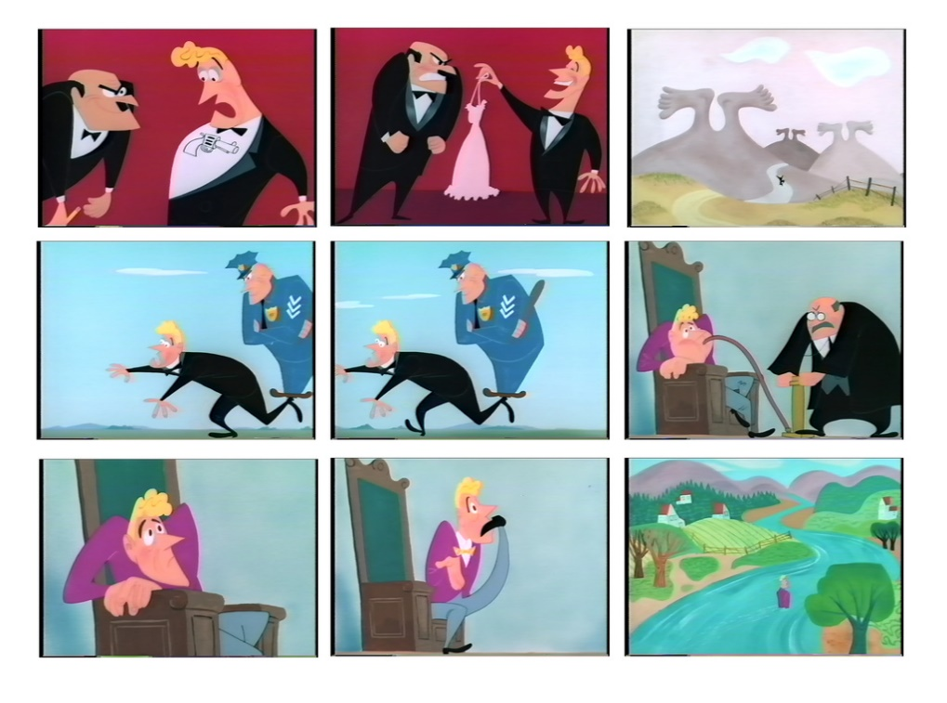

7.

"...to do a stretch in the jug."

"I was up against it..."

"...and felt myself go to pot."

"I raised a big stink."

"...let me talk to an undercover man."

"I went through a lot of red tape..."

"...he sprung me!"

"It sure felt good to stretch my legs..."

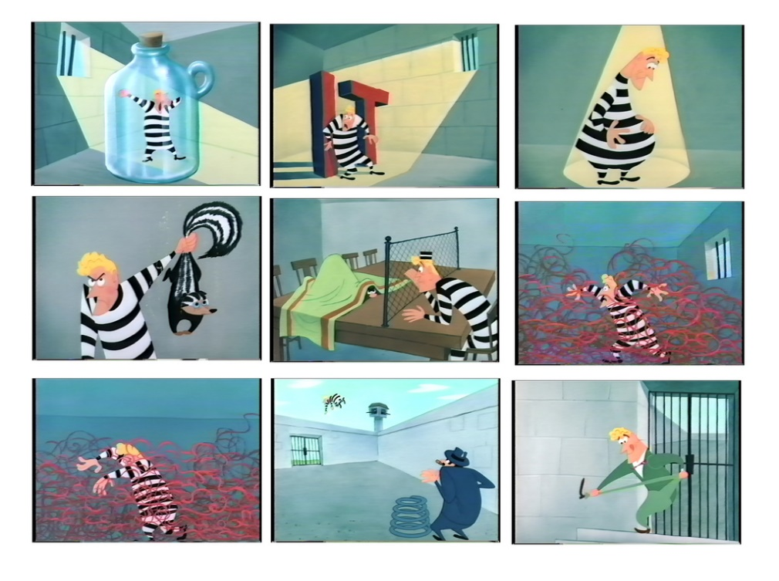

8.

"...I caught a Greyhound..."

"...I dropped in on Mary..."

"...and threw myself at her feet."

"But she turned her back on me."

"But she got on her high horse. I couldn't touch here with a 10 foot pole!""She wouldn't say a word. Guess the cat got her tongue."
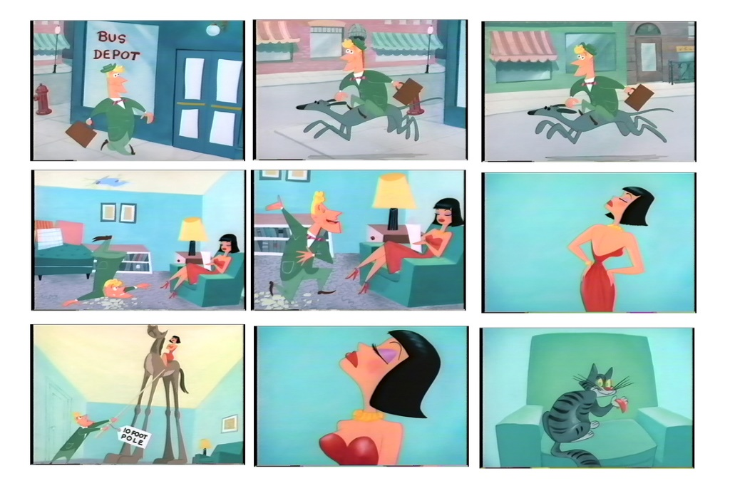

9.

"So, I walked out on her."

"After that, I went to pieces."

"...where a bunch of the boys were hangin' around."

"The guy at the piano played by ear."

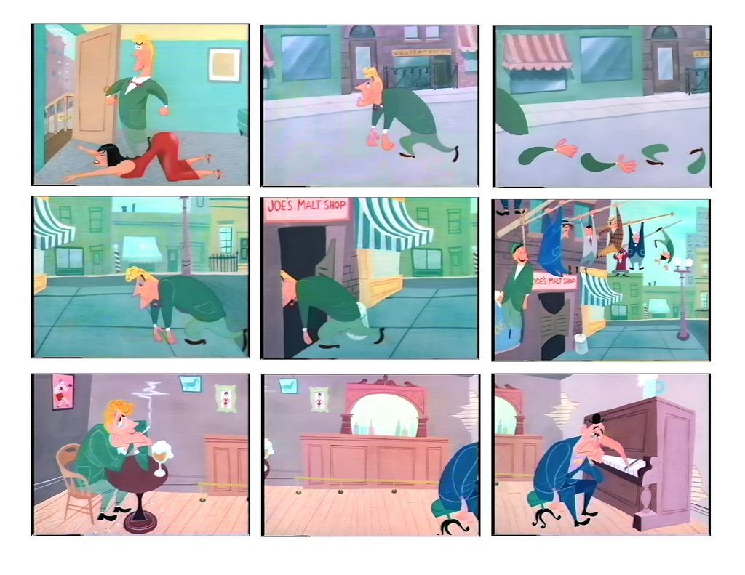

10.

"I felt a tug at my elbow..."

"We sat down and chewed the rag a while."

"I heard through the grapevine..."

"...Mary was going around with an old flame."

"That burned me up!"

"Because I knew that he was feeding her a line."
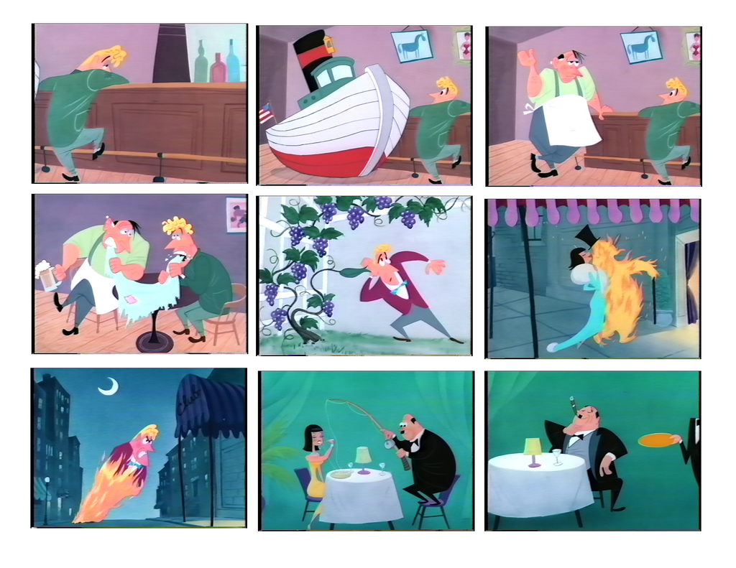
11.

"The guy really spent his money like water."

"I think he was connected with the railroad."

"As they danced, I tried to chisel in..."

"...but the guy got in my hair."

"Outside it was raining cats and dogs."

"I was feeling mighty blue."

"And everything looked black."

"But I carried on!"

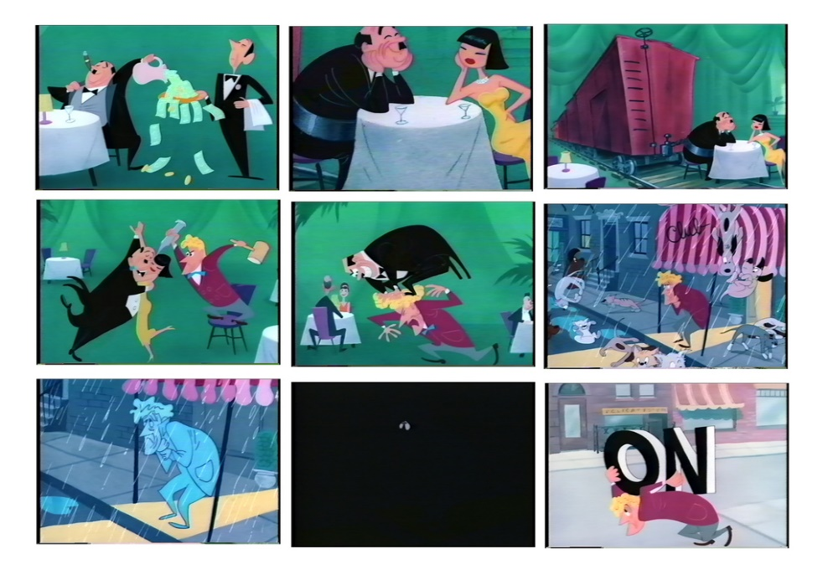

12.

"I went to the 1000 Islands."

"There, I became a beachcomber."

"...and a tear ran down my cheek."

"So I sends her a cable."

"The next day, she sends me a wire."

"I rushed back to the US on a cattle boat..."

"...and I hotfooted it over to Mary's apartment."
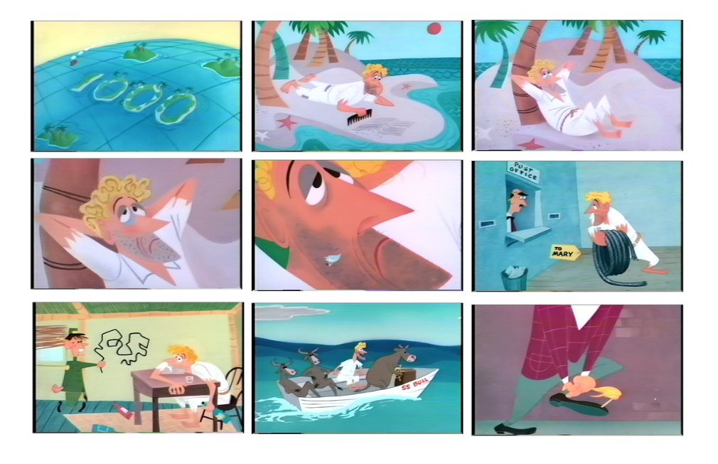

13.

"When I opened the door, I noticed quite a few changes..."

"Why Mary, she had a bunch of little ones."

"The groom had his hands full, too!"

"So, all this struck me so funny, I died laughing!"

